Module 6: Connecting with Your Audience

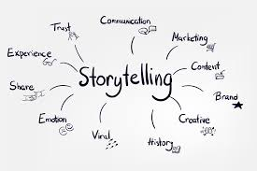
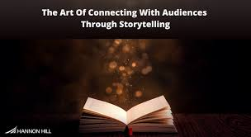
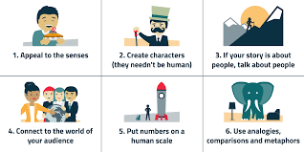

Module Metadata: Connecting with Your Audience (1 Hour)
Short Description
Master the art of audience engagement in storytelling. This module explores techniques like eye contact, rhythm, repetition, and idiophones to create immersive, interactive experiences that resonate emotionally and culturally — with applications in education, performance, and enterprise.
Long Description
Storytelling is a shared experience — and the audience is never just a spectator. In this module, learners will explore how storytellers build connection through rhythm, repetition, eye contact, and sound. They’ll learn how emotional engagement, adaptability, and participation transform stories into memorable moments. Drawing from oral traditions and performance techniques, learners will discover how audience connection enhances storytelling’s power — whether in classrooms, community spaces, or digital platforms. These skills are essential not only for cultural transmission but also for entrepreneurial success in media, branding, and public speaking.
Aims
- To develop skills in engaging audiences through interactive storytelling techniques.
- To highlight the role of emotional connection and adaptability in effective storytelling.
- To explore how audience engagement supports educational, cultural, and entrepreneurial goals.
Objectives
By the end of this module, learners will be able to:
- Apply techniques such as eye contact, rhythm, repetition, and idiophones to enhance storytelling.
- Foster emotional connection and active participation during storytelling sessions.
- Analyze how audience engagement influences message retention and impact.
- Reflect on how these techniques can be used in entrepreneurial contexts such as media, branding, and public speaking.
Learning Outcomes
Learners will:
- Demonstrate proficiency in audience engagement techniques.
- Evaluate storytelling performances for emotional resonance and interactivity.
- Apply engagement strategies to their own storytelling practice.
- Begin to position audience connection as a key asset in storytelling-based enterprises.

Storytelling is not just about delivering a narrative—it’s about engaging the audience and making them feel part of the experience. A great storyteller builds a connection through eye contact, rhythm, repetition, and idiophones, ensuring the audience remains captivated.

The Role of Audience Engagement
Audience engagement is the key to memorable storytelling. A storyteller must create an interactive experience where listeners feel involved rather than passive observers.
- Emotional Connection – Engaging stories evoke emotions, making the audience feel invested.
- Active Participation – Encouraging responses, questions, and reactions keeps the audience engaged.
- Adaptability – A storyteller adjusts their delivery based on audience reactions.
- Trust & Connection – Eye contact and interaction build rapport, making the story more impactful.
Studies show that storytelling enhances audience engagement by fostering emotional investment and making messages more memorable.
Eye Contact, Rhythm, Repetition, and Idiophones
These techniques enhance audience connection and storytelling effectiveness:
- Eye Contact – Establishes a bond with the audience, showing attentiveness and confidence.
- Rhythm – A well-paced story keeps listeners engaged. Speech patterns should flow naturally.
- Repetition – Reinforces key themes and helps audiences remember important moments.
- Idiophones – Sound effects (e.g., footsteps, thunder, water dripping) enrich the story’s atmosphere.
Oral storytelling traditions often rely on rhythm, repetition, and audience interaction to create immersive experiences.

Exercise: Find a storytelling video online and analyze how the storyteller engages the audience.
Assignment: Tell a short story to a group and gather feedback on audience participation.

